7. Chest injuries including chest drains, penetrating cardiac injuries and resuscitative thoracotomy

Chest drains

Chest trauma is common.

Only a minority of patients with chest trauma require surgical intervention.

Insertion of an appropriately sized correctly positioned chest drain is the only procedure required in the management of most chest injuries.

Indications:

- Potentially life-threatening conditions identified in the primary survey requiring a chest drain:
  - Tension pneumothorax
  - Open pneumothorax, in conjunction with closing / covering the open wound
  - Massive haemothorax

- Other indications:
  - ‘Large’ simple pneumothorax not under clinical tension
  - Any pneumothorax in a haemodynamically unstable patient
  - Any pneumothorax in a child who is intubated for transfer to another hospital
  - Bilateral pneumothoraces
  - Large pleural effusions
  - Formal drain after thoracostomy (best to insert drain in separate site)

Cautions:

- The presence of surgical emphysema is not an indication for a chest drain if no pneumothorax can be identified on imaging
  - Consider a chest drain in worsening surgical emphysema
- The identification of an asymptomatic pneumothorax on a Trauma CT scan is not an indication for a chest drain in an otherwise stable patient
- The presence of needle catheters in the 2nd intercostal space, mid-clavicular line that have been inserted prior to arrival in A&E does not mandate the insertion of a chest drain unless clinically indicated
- There is no evidence to support not inserting a chest drain in a patient with a symptomatic large haemothorax, for fear of releasing the tamponade effect. Large effusions usually cause tension, and these patients have a “B” problem due to their lung collapse as well as a “C” problem
- It is not mandatory to insert a chest drain in a patient with an asymptomatic pneumothorax who is to be intubated and ventilated for theatre, although awareness of the presence of a pneumothorax is essential.
- It is mandatory to insert a chest drain in a patient with pneumothorax who is intubated for transfer.

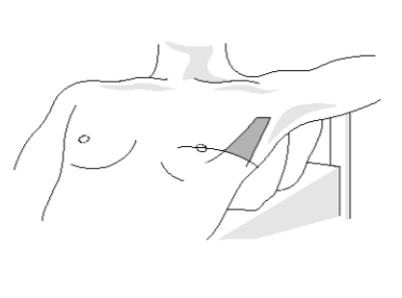
Procedure

- Chest drain size is dependent on age/size of the child, but a 20Fr chest drain should be sufficient in most situations. In the trauma situation, small bore Seldinger drains should be avoided unless there is a specific indication after discussion with an appropriate specialist team
- Insertion is in the triangle of safety, as per ATLS/APLS guidelines on chest drain insertion. If a small bore Seldinger drain is considered appropriate it can be inserted at the same site.

  - Position patient if feasible
  - In a conscious, alert child, give sufficient local anaesthetic & enough time to work
  - Assess length of drain needed - insertion site to apex or base depending upon need
  - 5th intercostal space + anterior axillary line
  - Incision through skin and subcutaneous tissues to intercostal muscles
  - Blunt dissection with large clip + “above rib below” to avoid intercostal nerves and vessels
  - Insert drain to required length, angling drain posteriorly in most cases
  - Ensure all holes are within chest cavity
  - Secure drain (suture or tape)
  - Connect to underwater seal
  - Place simple dressing around drain site
  - Obtain a CXR to confirm position, unless going for chest CT

- Cautions:
  - Beware the rare patient with chest scars and previous chest surgery - adhesion risk
  - A ruptured left hemidiaphragm and an intrathoracic stomach can mimic a pneumothorax
  - A ruptured right hemidiaphragm and an intrathoracic liver can mimic an effusion
  - NEVER clamp a chest drain

- Note:
  - Underwater seal drains are not recommended for transport – a Heimlich valve, pneumostat or dry chest drainage system is preferred

For further guidance on analgesia (other than local anaesthetic) refer here.
Management of the patient with a chest drain
- What to measure:
  - Swinging or not
  - Presence of an air leak
    - Constant
    - On expiration
    - On coughing
  - Fluid
    - Volume
    - Colour / consistency
- When to measure:
  - Hourly
  - 24-hour total
- Inspect the drain site
- Suction:
  - Avoid suction on chest drains unless advised by paediatric surgery
- Cautions:
  - In most trauma situations the effusion will be haemorrhagic
  - Involve early the paediatric surgical team involved in the patient’s care, or if in a Trauma Unit discuss with a paediatric surgeon at the MTC, if there is
    - persistent air leak
    - persistent blood loss after initial drain insertion
    - effusion suggestive of gastric contents (which may indicate oesophageal rupture or a ruptured hemidiaphragm with an intragastric drain)

When to remove a chest drain

- When the reason for the chest drain insertion is gone, the drain should be gone
- When the drain has stopped draining it is no longer needed
- In a pneumothorax, there should be no air leak for 24 hours
- Usually there is no need for a stitch to close the drain hole
- Chest drain removal is usually a two-person job – one person to remove the drain and the other to cover the wound.
  - There is some evidence (following elective thoracic surgery) that removing the drain at the end of full expiration leads to a lower incidence of non-clinically significant pneumothorax. This can be difficult in children
- It is not mandatory to obtain a CXR following drain removal, if the patient remains well and there are no concerns on auscultation. If in any doubt, a CXR is indicated
- Caution:
  - Occasionally drains stop working because they are blocked, kinked or dislodged
  - Assess patient clinically +/- CXR if this suspected

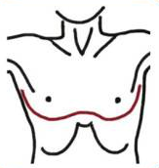
Resuscitative thoracotomy – see Appendix 3

Loss of vital signs < 10 minutes and 1:20 chance of response

Indications
- Penetrating trauma to chest/epigastrium: if NO signs of life
  - Pupillary response
  - Spontaneous ventilation
  - Presence of carotid pulse
  - Measurable or palpable BP
  - Extremity movement
  - Cardiac electrical activity
- Blunt trauma to chest: if they lose cardiac output in front of your eyes
Contraindications
- Prehospital CPR performed for >15 minutes after penetrating chest injury without response
- Prehospital CPR performed for >10 minutes after blunt chest injury without response
- Presence of coexistent injuries that are unsurvivable, e.g. severe head trauma (an exception may be the patient who is a potential organ donor)
- Asystole is the presenting rhythm, and there is no pericardial tamponade
Findings / Interventions in order most likely to save life
- Pericardial tamponade / Relieve
- Haemorrhage / Control
- Open CPR
Procedure
- Supine – arms as far from chest as possible, crucifix position if feasible. Venous access to both arms simultaneously
- Bilateral antero-lateral open thoracostomies (same interspace) - see if improves condition
- Always do a clamshell (Flaris et al. World J Surg 2015, 39: 1306-1311)
- Be bold, don’t hesitate - aim to enter pericardium in <90 seconds
- Simple kit - scalpel, forceps, Tuff cuts (big scissors), Big clip + Gigli
- Join two thoracostostomies, as one thoracotomy - like an underwired bra - NOT straight across
- Open Pericardium vertically - avoid phrenic nerves
- Cardiac wounds - finger pressure on hole (NOT IN), close with sutures or staples
- Descending aortic compression early - flat of hand through left chest, compression against spinal column
- Have blood ready - wait until haemorrhage controlled, fill heart before releasing aortic compression
- After ROSC, control internal mammary arteries
See also Appendix 3 - Resuscitative thoracotomy algorithm and useful links

Appendix 3 – Resuscitative thoracotomy flow chart

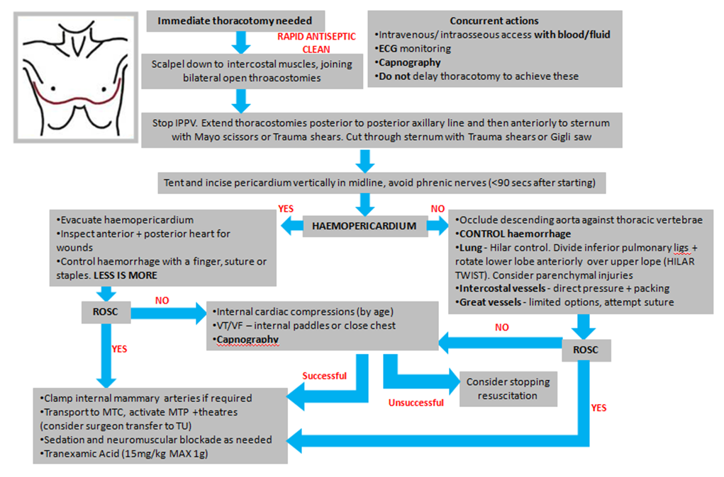

Useful links
https://emcrit.org/racc/procedure-of-thoracotomy/
http://www.trauma.org/archive/atlas/clamshell.html
http://emj.bmj.com/content/22/1/22
https://www.wymtn.com/uploads/5/1/8/9/51899421/traumatic_cardiac_arrest_-_indications_for_resuscitative_thoracotomy.pdf

