14. Burns – initial management and referral criteria

First aid

Management

Calculate and document Total Burn Surface Area (TBSA) and depth using a paediatric Lund and Browder Chart – Appendix 8

Less than 10% TBSA | No fluid resuscitation if oral intake is adequate
10% or more TBSA | Calculate resuscitation fluid requirements using the modified Parkland formula

Parkland formula
Fluid volume (ml) = weight (kg) x TBSA x 3

Divide total calculated fluid volume by two and then:
- Complete the first half by 8 hours from the time of the burn
- Give the second half over the next 16 hours

Give Hartmann’s solution (preferred) or 0.9% Sodium Chloride for resuscitation.
Additional maintenance fluids should be given +/- Potassium Chloride.

Other priorities
Don’t forget analgesia

- Application of a dressing helps with pain but additional analgesia is usually required
- Does the patient require tetanus prophylaxis?
- Avoid prophylactic antibiotics unless otherwise indicated

Referral criteria

Children with a burn and other life-threatening injuries should be transferred to the nearest Children’s MTC.

Refer to a Burns Unit if:
- Age < 6 months
Discuss potential referrals with on call registrar
at local burns unit before regional transfer

- Non-accidental (also refer to the local paediatric team)
- Special area – face, hands, feet, perineum, flexures
- Circumferential burn
- Any thickness burn of 2% or more Total Body Surface Area (TBSA)
- Any full thickness burn greater than the size of the patient’s fingertip
- Significant inhalational injury
- Chemical, radiation, electrical or friction burn and any cold injury
- Any unwell or febrile child with a burn
- Any child with a suspicion of toxic shock syndrome
- Any burn that has not healed at 14 days

In the Leeds Children’s MTC region burns care is co-ordinated from the Burns Unit at Pinderfields via Plastic Surgery Registrar on 0844 811 8110.

In the Sheffield Children’s MTC region burns care is co-ordinated from the Burns Unit at Sheffield Children’s Hospital (SCH). The Plastic Surgery Registrar on-call should be contacted Mon-Fri 0800-1600 via SCH on 0114 271 7000 and out of hours via Northern General Hospital on 0114 243 4343.
Patients requiring HDU or PICU level care should be referred
via Embrace on 0114 268 8180
sheffieldchildrens.nhs.uk/embrace

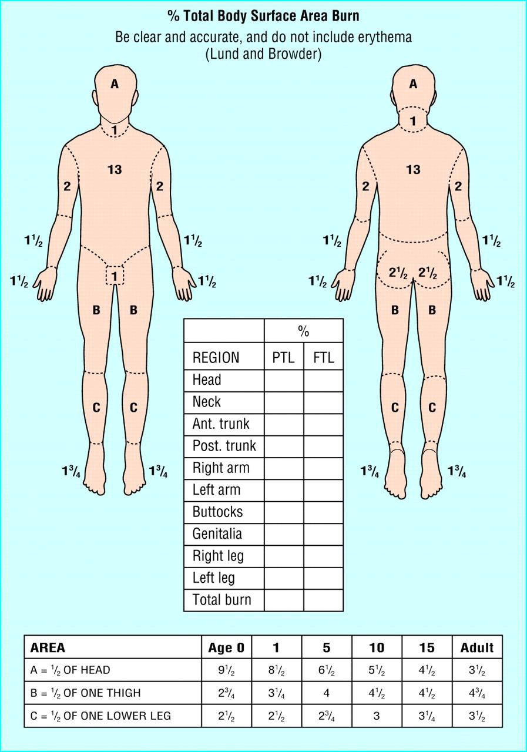
Appendix 8 - Paediatric Lund and Browder chart

