**17. Imaging and interventional radiology**

*These guidelines have been adapted from the Leeds Major Trauma Centre Imaging in Paediatric Major Trauma guidelines Written by Dr Annmarie Jeanes (Consultant Paediatric Radiologist).*

*They should be read in conjunction with the following documents:*

*BFCR(14)8 Royal College of Radiologists Paediatric Trauma Protocols, Aug 2014*

[*https://www.rcr.ac.uk/publication/paediatric-trauma-protocols*](https://www.rcr.ac.uk/publication/paediatric-trauma-protocols)

*NICE CG 176 Head Injury: Assessment and early management, Jan 2014 (updated Jun 2017)*

[*https://www.nice.org.uk/guidance/cg176*](https://www.nice.org.uk/guidance/cg176)

**Background and risks from ionising radiation**

The ‘routine’ recommendation of head - symphysis CT scanning in adult patients cannot be directly transferred to children. The spectrum of trauma, surgical management and outcome is different from adults, and thus ‘head to toe’ whole body CT is often not necessary, or indeed appropriate.

Despite the benefits of CT, the disadvantage is the exposure to ionising radiation.

Children (particularly girls) are at greater risk than adults of detrimental effects from ionising radiation. This has been demonstrated in epidemiologic studies of exposed populations.

The reasons for this are twofold:

1. Their longer life expectancy results in a larger window of opportunity for the effects of radiation damage to be expressed.

2. Children’s organs are more radiation sensitive. Although the energy imparted from the radiation exposure is less than in adults, the corresponding organs are also smaller, resulting in a marked increase in organ dose ‐ and therefore patient‐effective dose. A 1 year old infant is 10–15 times more likely to develop cancer than an adult for the same exposure and radiation dose.

**The ALARA Principle**

As medical practitioners it is our responsibility to ensure that exposure to medical ionising radiation for all patients should always be kept to a minimum and the ALARA principle (an acronym formed from the phrase “As Low as Reasonably Achievable”) should be followed.

* Any imaging involving ionising radiation must be justifiable
* For an individual child, the benefits of a properly performed and clinically justified CT should always outweigh the risks
* The exposures should be adjusted accordingly to ensure a diagnostic study at the lowest dose ie specific Paediatric weight based protocols should be used.
* Multiple phase CT scans should only be used when clinically appropriate.

**Choice of imaging modality**

The most appropriate imaging modality will be covered in more detail by anatomical area in the subsequent sections. However, the following general statements regarding each modality can be made.

**Ultrasound**

In the acute paediatric trauma setting there is no role for ultrasound outside of assisting in interventional procedures.

**MR**

In the acutely injured child, magnetic resonance (MR) imaging is primary reserved for potential spinal cord injury, though it is acknowledged that access to MR imaging may be difficult.

**Plain radiography**

The value of a normal radiograph for specific areas (chest and c-spine) should not be underestimated.

The chest radiograph is the primary investigation for blunt chest trauma and should be performed as part of the primary survey in children who have been the victim of major trauma.

If there is clinical suspicion of an isolated c-spine injury, clinical examination and plain c-spine radiographs are normally sufficient to exclude bony injury.

A primary survey pelvic radiograph is not indicated in the paediatric population.

**CT**

As discussed whole body CT is often not necessary, or indeed appropriate. However, targeted use of CT forms the major component of major trauma imaging in children. The indications for CT will covered by anatomical area in the subsequent sections.

Although whole body CT should not be considered a routine investigation in injured children, it can be used in selected cases where patients have clearly suffered severe injury to more than one body region and the overall risks and benefits have been carefully considered.

If CT is deemed the most appropriate investigation, appropriate dose reduction procedures must be in place.This includes dose reduction software, iterative reconstruction software and use of judicious kilovolt and milliampere reduction. Radiosensitive areas such as the lens, thyroid and breast should be avoided where possible.

**Chest trauma**

The chest radiograph is the primary investigation for blunt chest trauma and should be performed as part of the primary survey in children who have been the victim of major trauma.

Further imaging (with contrast-enhanced chest CT) should be dictated by the nature of the trauma, the clinical condition of the child and the initial radiographic findings.

Isolated chest CT can be performed in the arterial phase, however when the chest is imaged together with the abdomen and pelvis, a single-volume dual-contrast acquisition (e.g. Camp Bastion contrast) is advised to minimise radiation burden.

Chest CT is not required if the chest radiograph is normal, the patient is conscious and clinically stable as it is unlikely to lead to a change in management.

Penetrating trauma is an indication for contrast-enhanced chest CT due to the incidence of occult vascular injury.

**Head trauma**

The RCR guidance on imaging in paediatric trauma states:

“CT is the primary investigation for cranial imaging in the child who has suffered head trauma. It displays high sensitivity and specificity for identification of traumatic brain injury and is readily available in most centres. However the dose of ionising radiation required for cranial CT has been demonstrated to be associated with an increased incidence of cancer and it should not be used for all children with head injury. The indications for cranial imaging have therefore been evaluated by the National Institute for Health and Care Excellence (NICE) and are summarised in the algorithm presented.” (Figure 2).

“All children with head injuries should be assessed by an appropriately trained professional within 15 minutes of hospital presentation, and immediately if there is any reduction in conscious level. Adequate resuscitation, clinical examination and administration of analgesia should take place in the process of deciding whether to perform CT.”

“Isolated head injuries are common in childhood and fulfilling the criteria for a cranial CT scan is not an indication on its own for a CT of the cervical spine or any other body part.”

“Cranial CT should be performed before administration of intravenous contrast. Following the ALARA principle, avoidance of the lens should be optimised.”

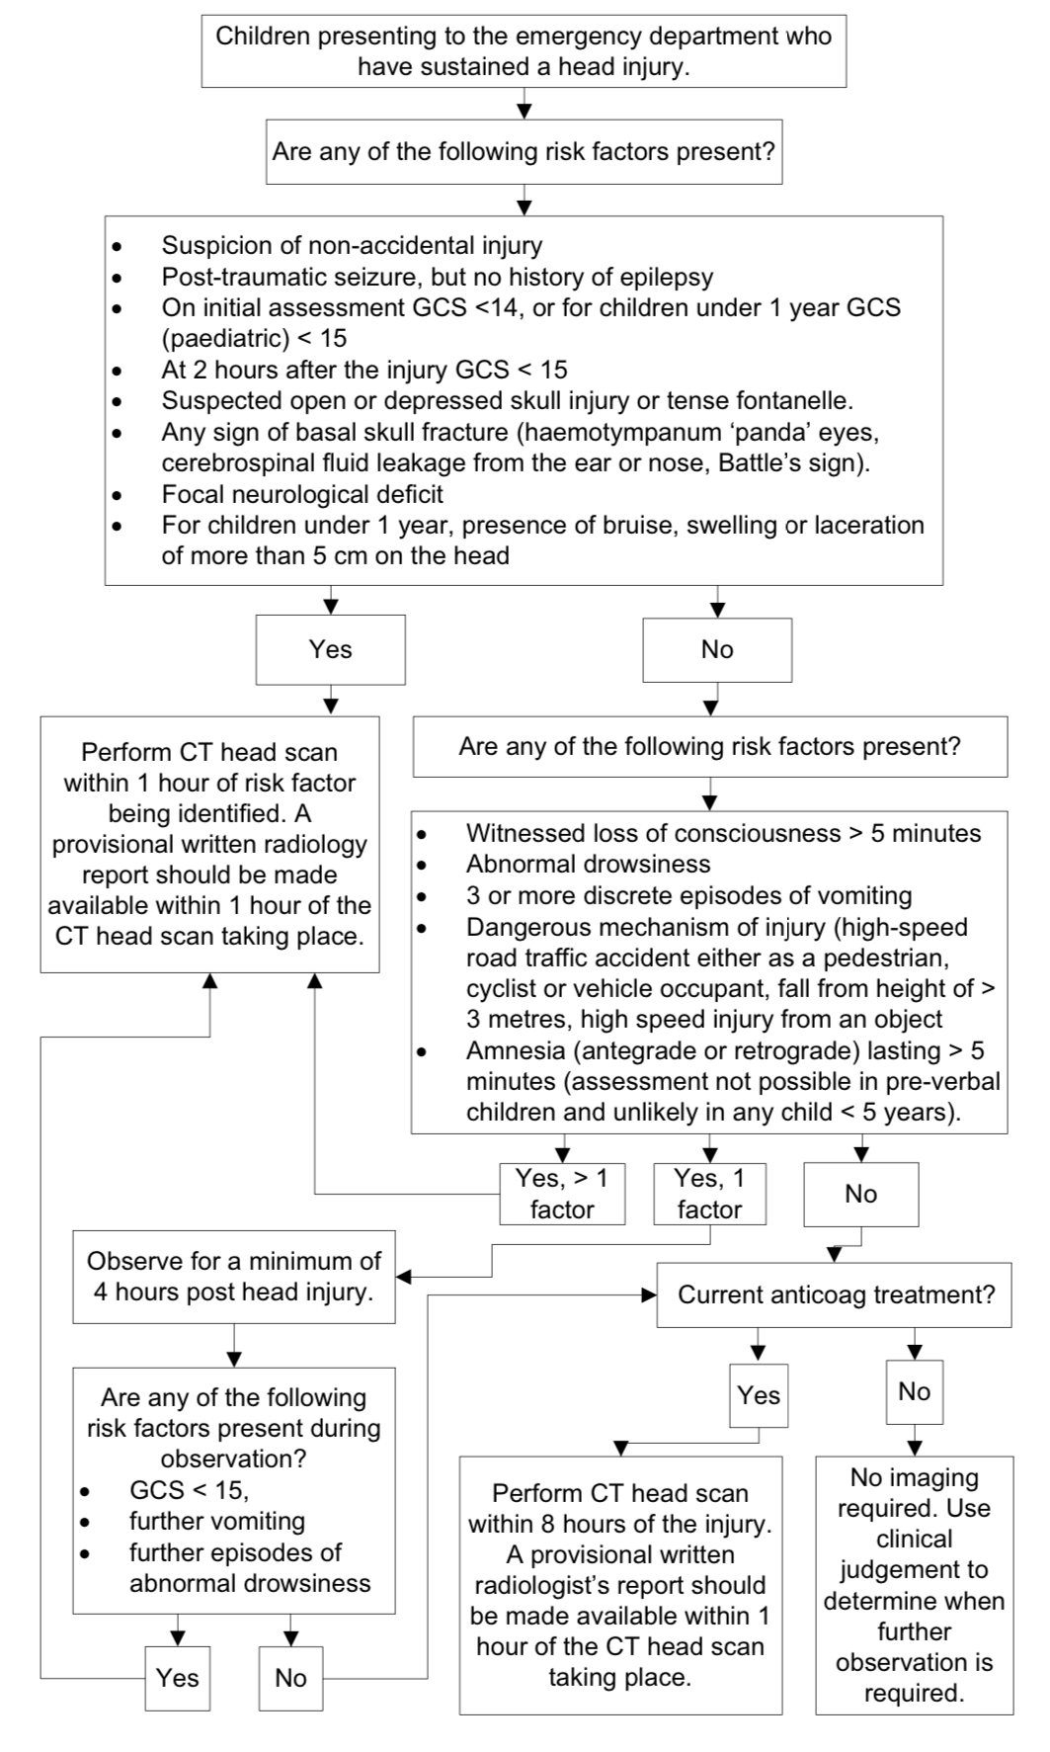

**Figure 2. Selection of children for a CT head scan** National Institute for Health and Care Excellence. *CG 176 Head Injury: Assessment and early management.* Jan 2014 (updated Sep 2019)

**Cervical spine trauma**

Paediatric cervical spine injury is uncommon.

Appropriate clinical evaluation must be undertaken before imaging is performed as it is an anatomical area that is relatively radiosensitive. Prior to cervical spine imaging a full history and examination must be performed where possible, with any imaging being complementary to other features elicited. Imaging should not be used in isolation as a diagnostic measure.

When spinal injuries do occur in children they are more likely to involve the cervical spine. This is due to both physiological and anatomical differences between young children and adults. These include a relatively high fulcrum, larger head, horizontal facets, flatter vertebral bodies, and ligamentous laxity.

Initial imaging of the cervical spine may be with plain radiographs or CT scan depending on the clinical situation.

The radiation burden associated with imaging of the cervical spine in children is significant.There is a linear relationship between radiation exposure to the neck in children and the development of thyroid cancer, with the strongest association being in children < 15 years at the time of exposure. CT is superior in the diagnosis of fractures; however the dose to the thyroid is reported to be 90- 200 times higher with CT, the greatest risk being in children less than 5 years old.

Given the propensity of ligamentous injury and radiation risks in children, the cervical spine should, where possible, be ‘cleared’ using a combination of conventional radiography and clinical examination. Plain radiographs still have a substantial role in alert, symptomatic patients. Adequate radiographs of the cervical spine may exclude significant bony injury and obviate the need for CT. Where plain radiographs are indicated, an adequate cervical spine series must include:

1. Lateral cervical spine X-ray to include the base of skull and the junction of C7 and T1
2. Antero-posterior cervical spine x-ray to include C2 to T10 and
3. An adequate peg view if attainable.

Peg views may be difficult in young children. However it is recommended that if they can obey commands and open their mouth a peg view should be attempted.

In a stable child undergoing cranial CT, discussion between senior radiologists and senior clinicians as to the most appropriate imaging of the neck (where clinically indicated) is advised. It is inappropriate to perform cervical spine imaging automatically when performing cranial imaging without appropriate discussion.

It must also be remembered that due to ligamentous laxity in children, both plain radiography and CT may be normal despite significant ligamentous and spinal cord injury. In children less 5 years old, given the radiation burden from CT and insensitivity of CT to ligamentous injury, MRI rather than CT should be considered. MRI should also be considered as the primary imaging modality where there are definitive neurological signs.

Figure 3 shows the process for selection of children for imaging of the cervical spine employed in the NICE guideline (CG176) which refers primarily to management of head injury. Please note that presence of head injury alone is not sufficient to enter the starting point of the algorithm; rather there must be clinical suspicion (based on history or examination) of potential cervical spine injury.

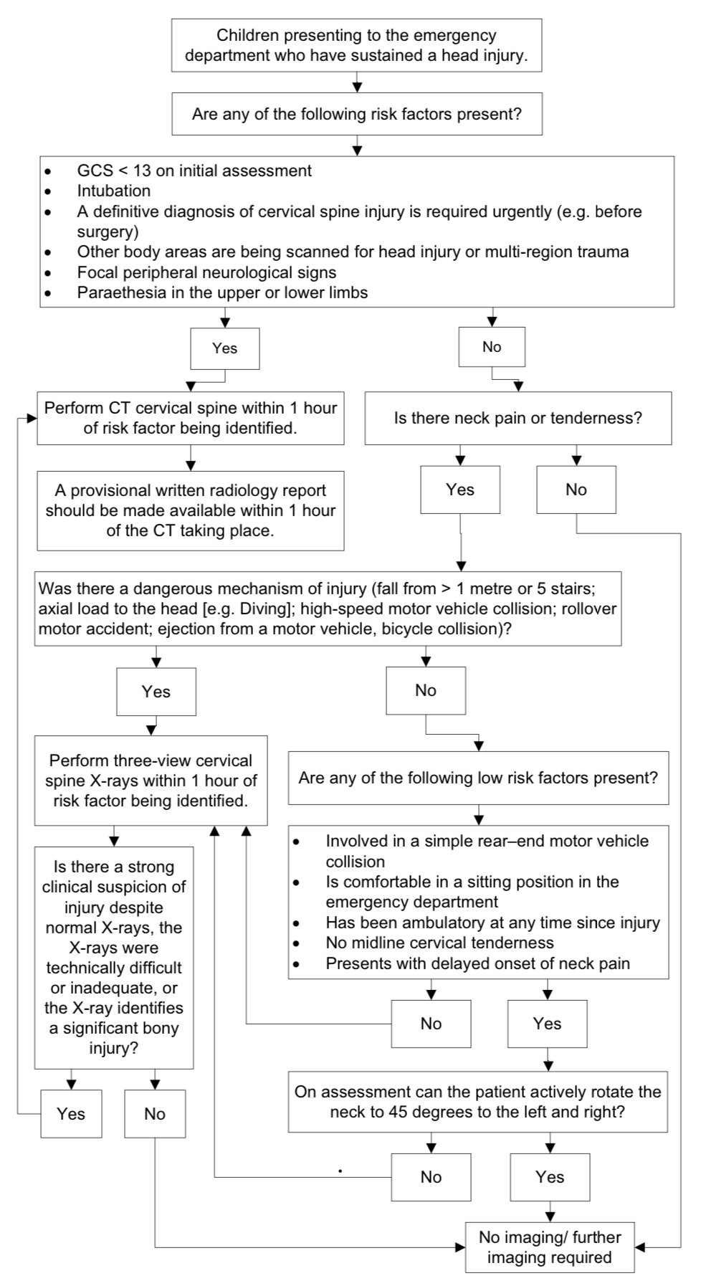

**Figure 3. Selection of children for imaging of the cervical spine.** National Institute for Health and Care Excellence. *CG 176 Head Injury: Assessment and early management.* Jan 2014 (updated Jun **2017)**

**Abdominal and pelvic trauma**

The majority of abdominal trauma in children and adolescents occurs secondary to a blunt impact, with RTCs, pedestrian vs. vehicle collisions and falls being the most frequently reported causes. Other common mechanisms of injury include recreational accidents, particularly bicycle handlebar injuries, off road quad biking and contact sports. These seemingly trivial mechanisms may however result in severe injuries. Abdominal trauma is rare in infants and young children, with head injury being much more frequent. The most common cause of abdominal trauma in this age group is inflicted trauma.

Contrast-enhanced CT is the modality of choice for the assessment of acute traumatic intra-abdominal injury. There are no mechanisms of injury which mandate abdominal CT as an isolated factor. Decision to perform abdominal CT should be made on the basis of the clinical history and examination.

The following clinical variables have been found to be associated with intra-abdominal injury and may indicate the need for abdominal CT:

* Lap belt or handle bar injuries
* Abdominal wall ecchymosis
* Abdominal tenderness in a conscious patient
* Abdominal distension
* Clinical evidence of persistent hypovolaemia; for example, persistent unexplained tachycardia
* Blood from the rectum or nasogastric tube.

When CT is clinically indicated a single-volume dual-contrast acquisition (e.g. Camp Bastion contrast, figure 4, overleaf) is advised to minimise radiation burden. As the abdomen and pelvis form one anatomical compartment, the scan field should extend to the symphysis pubis inferiorly. If there is a high likelihood of active arterial bleeding multi-phase imaging (arterial and portal venous +/- delayed) may be required. Delayed phase imaging / CT cystography may be required if the initial imaging suggests suspected renal / bladder trauma respectively. Multi-phase imaging and CT cystography would normally be performed in the tertiary referral centre where ultimate management will take place.

Pelvic fractures are rare in children and therefore a primary survey pelvic radiograph is not indicated in the paediatric population. In the context of major trauma the bony pelvis will be included on CT.

**Interventional radiology**

Paediatric patients who require interventional radiology should be treated in a dedicated tertiary referral centre by an expert in interventional radiology with appropriate skills where possible. The child with major trauma will be transferred to the Major Trauma Centre (MTC) according to the usual major trauma pathway with direct ED to ED referral (see Section 3). It is imperative that all relevant imaging is transferred to the tertiary referral centre, ideally electronically via PACS.

**Preparation for CT and scan technique**

* In stable patients, obtain chest radiograph prior to CT.
* Discuss clinical details with radiologist, agree on imaging strategy and place request.
* If required, head and c-spine CT is performed unenhanced (no administration of IV contrast)
* If required, thoracic, abdominal and pelvic CT is IV contrast enhanced. Ensure intravenous access prior to transfer. This should be the largest cannula possible, ideally in the right ACF.
* IV Contrast: single-volume dual-contrast acquisition (e.g. Camp Bastion contrast, Figure 4)
* Clamp the urinary catheter if present.
* If necessary, decompress the stomach with an NG tube.
* Enteric contrast is not required. This includes penetrating trauma.

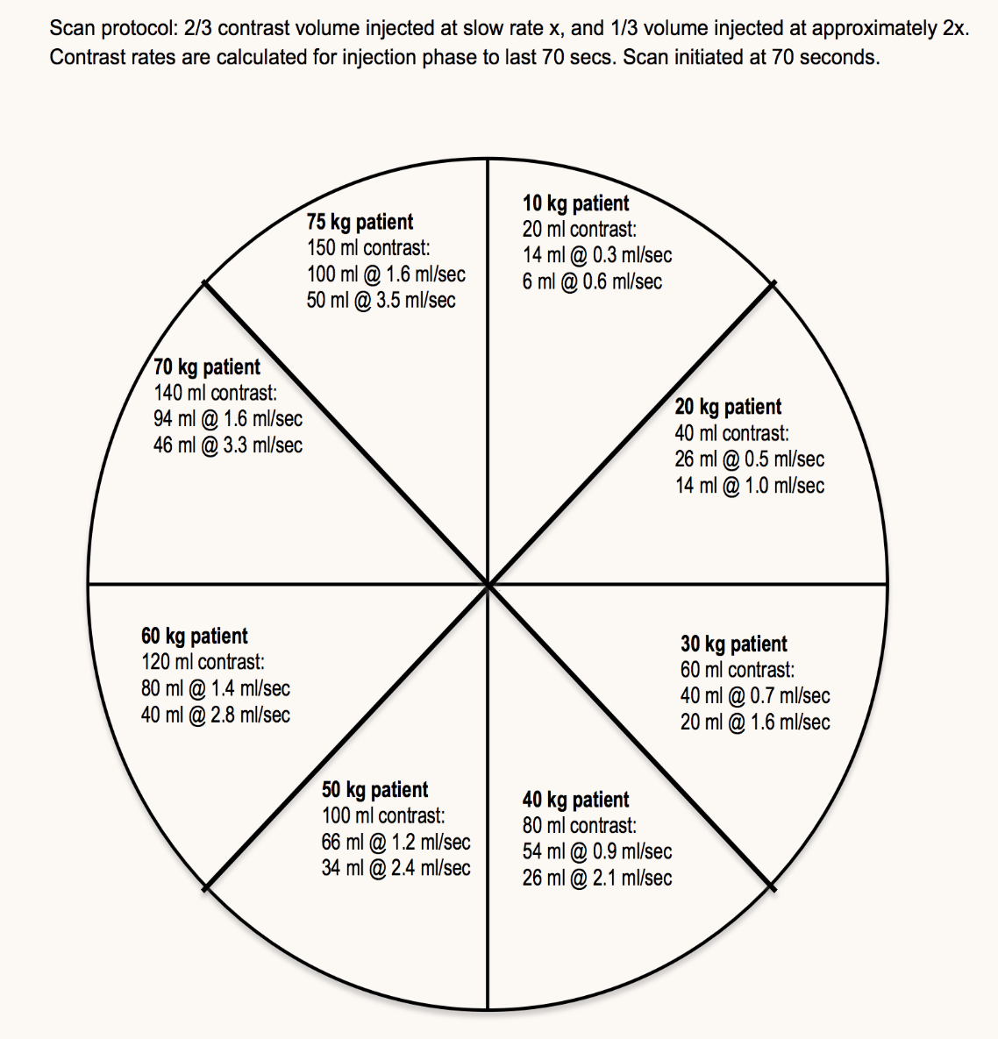

**Figure 4. Camp Bastion contrast wheel.** Developed by Dr Richard Miles. *BFCR(14)8 Royal College of Radiologists Paediatric Trauma Protocols*. Aug 2014.

**Reporting**

* An acute primary assessment report (example provided, Appendix 10) should be completed immediately, ideally prior to the patient leaving the CT department.
* A full report should be available within 1 hour. This may be a provisional report, in which case a consultant verified report should be completed within 24 hours.

**Appendix 10 – Imaging reporting template**

**Acute primary assessment report.** *BFCR(14)8 Royal College of Radiologists Paediatric Trauma Protocols*. Aug 2014.

|  |  |
| --- | --- |
| Patient name |  |
| Patient number |  |
| Date of scan |  |

**To guide initial management only. A formal report will follow. The trauma team will be notified of any major alterations to this primary assessment.**

**Primary assessment trauma plain films (for stable children)**

Cervical spine

|  |  |
| --- | --- |
| Normal | No CT C-spine indicated |
| Abnormal / clinical suspicion | CT C-spine required |

Chest X-ray

|  |  |
| --- | --- |
| Normal | No CT chest indicated  Proceed to CT abdo / pelvis if needed |
| Abnormal / clinical suspicion | CT TAP required |

**CT scanning preliminary review**

|  |  |  |  |
| --- | --- | --- | --- |
| **Airway** | | | |
| ET placement | N/A | Satisfactory | Unsatisfactory |
| Airway obstruction | | Yes | No |

|  |  |  |  |
| --- | --- | --- | --- |
| **Breathing** | | | |
| Contusion | | Yes | No |
| Laceration | | Yes | No |
| Pneumothorax | | Yes | No |
| Chest drain placement | N/A | Satisfactory | Unsatisfactory |

|  |  |  |  |
| --- | --- | --- | --- |
| **Circulation (bleeding)** | | | |
| Pericardial effusion | | Yes | No |
| Thoracic injury | | Yes | No |
| Abdominal injury | Retroperitoneal | Yes | No |
|  | Visceral | Yes | No |
| Pelvic injury | | Yes | No |
| Soft tissue | | Yes | No |

|  |  |  |
| --- | --- | --- |
| **Disability** | | |
| Intracranial bleed / oedema | Yes | No |
| Major spinal injury (cord compromise) | Yes | No |

|  |  |
| --- | --- |
| **Comments** | |
|  | |
|  | |
| Name of radiologist |  |
| Time |  |